WORK PRACTICUM REPORT
FOR
Olufunto Akinyemi
A00419429
In
Partial fulfillment for
Master’s in Computing & Data Analytics
Saint Mary’s University
4th June to 9th November 2018
(23 weeks)

Introduction:
Saint Mary’s University master’s program in Computing & Data Analytics requires that an applied learning with industry must be carried out as part of the requirements of the program. This report together with the daily work log summarizes some the activities embarked upon during the co-op term.

Organization: Royal Bank of Canada (RBC)
Location: Bedford, Halifax, NS.
Department: Payments and Trade Operation (PTO).
Unit: Business Performance.
Manager: Joey Duguay.

As part of the onboarding process, it was mandatory to attend trainings and complete all required exams for new intakes. The trainings and exams are listed below:

- RBC Code of conduct training.
- RBC Privileged Security User training.
- RBC Health and safety training.
- RBC Combating money laundering and terrorist financing training.
- RBC Introduction to risk management training.
- RBC privacy and security training.

Different task and activities were assigned periodically and on a need basis by the Manager. The following shows the various activities/projects/hackathons embarked upon during the co-op term.

Tableau Dashboards Development
The goal as defined by the manager was to design dashboards that reports on operator’s performance within a period for team leads, operators and senior management. The below items are the reported areas:
- Average Handling Time.
The Average Handling Time (AHT) dashboard segment reports the average handling time recorded for an operator for a period. The AHT is calculated by dividing the total time taken by the total number of items processed in the period.
- Credit per Hour.
The credit per hour dashboard segment stems from the newly developed performance incentive scheme developed by the organization. The aim is to give fair incentives to all operators irrespective of the queue operators might have worked by introducing weights for each queue. The processing times required within each work queue vary hence the need to ensure fairness. Weights for each queue was developed by the Manager.
- Operator Errors.
The errors dashboard segment displays the cumulative errors reported for operators according to the severity (Low, Medium, and High).

- Transactional Volume
The volume segment reports the volume for all period.
The above named areas formed the segments for the dashboards created for team leads, operators and senior management. The distinguishing areas for the 3(three) dashboards was the level of detail and aggregation. By nature, the management dashboard displayed highly summarized report while other reports had a finer level of detail/granularity.
The image below shows the Credit per hour, Errors and Volume segments in the management dashboard.

The above image shows the operator dashboard segments for volume, error and average handle time.
The above shows the Credit per hour segment for the operators. The ranking for the operators have been color coded to clearly differentiate between exceptional, outstanding, high performing and developing operators.
A total of six (6) reports and two (2) dashboards were developed during the work term for senior management and operators. Below is a brief description of the reports:
Errors Report: The reports shows the priority level, the quantity for each month.
Average Handling Time Report: This report is to show the average handling time it took operators in different queues to complete their task.
Volume Report: Shows the total volume of tasks completed for each operator in different work streams/queues.
The above three (3) reports were created for both operators and senior management. The operator report had a finer level of granularity while the senior level report showed high level rolled up figures of the operators report.

Error Extraction Program
Statement of Problem:
The reporting of errors committed by operators have been a manual and time-consuming process where team leads are required to provide the errors data for group reporting. This process poses a risk of errors been under-reported or overstated due to the manual process involved.
Description of Solution
The solution developed was to eliminate the manual process and provide accurate reporting of errors from the system without recourse to the team leads. This provided the advantage of accurate and correct reporting and also frees team leads of the man-hours required to capture and document errors.

The program polls a specified input directory and consumes all files (audit exception report) through a python file (auditreader.py). The program extracts, cleanse and assigns data to missing values and also creates a sequence for each item. The output from this file is handed off to SQL Loader utility to provide a fast load into the relational database (Oracle XE) along with the control file created for the load by the pycontrol.py program.

Upon successful data load, a process kicks in to run various PL/SQL algorithm to extract the different categories of error and loads data into work tables created for each operation queue.
R script is subsequently called to extract and write the report output to a dedicated folder.

The program completes with some garbage collection activities by clearing the input and other directory and deletes database records in readiness for the next run. Below show a technical schematic of the program architecture.

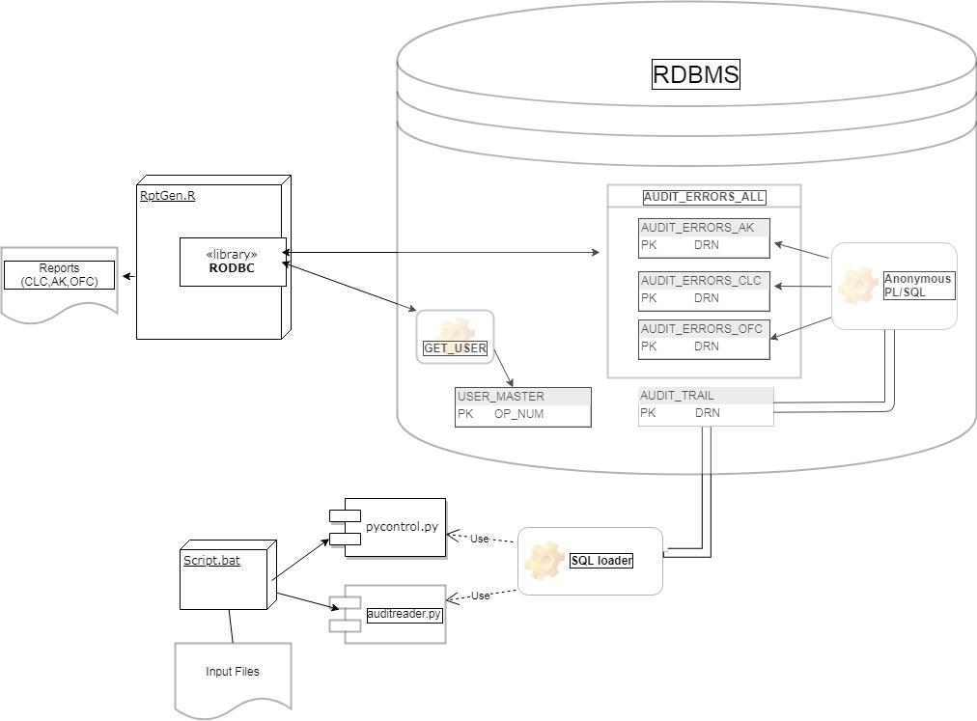

All source files for the program are contained in the appendix.

During the course of the work practicum, I also participated in two (2) challenges which shall be discussed subsequently.
Communication Problem with CWM Program Office
Contingent Workforce Management (CWM) program office oversees the onboarding, management and payment of contractors through payroll suppliers within the organization. This is done through staff augmentation request, statement of work contracts and independent management.
As result of this role, there is an immense amount of communication involved throughout this process hence the team was tasked with how to enhance communication and to improve the overall satisfaction as well as reduce the frustrations encountered as a result of the communication volume.
To proffer a solution, the stakeholders of the CWM were identified in order to clearly dimension the challenges faced by each stakeholder group.
Focus group meetings and surveys were administered to the different stakeholders and the following were identified as the key concerns which affects the communication problem.
- Hiring managers and suppliers are not reading documentation/e-mails.
- Some documents provided to hiring managers contained insufficient directions.
- Lack of clarity.
- Duplication of email responses.
- Lack of clarity on SLA’s, overall processes and escalation process.
- No central information base for users to access information.
In order to proffer a solution to the problem, the following were agreed as the objective to which the solution must focus.
- Promote the use of CWM within the organization.
- Centralize the activity ,information and documentation through connect. (Connect is RBC’s internal portal used to communicate and share information internally).
- Identify the distinct types of contracts concisely.
- Reengineer the use of shared inbox system which is currently used to receive requests.
- Communicate SLA’s etc.

The detailed action plan consists of three proposed solutions to meet the objectives aforementioned:
- Ticketing System
- Self-help Tool
- Connect Site

Ticketing System
A ticketing system provides a platform to track and resolve communications for the program and its clients that would be uniform across all teams. It would automate the time-consuming tasks associated with manually filling out and consolidating trackers, provide greater insights through the automated generation of data, set clear expectations for clients and employees, foster business continuity, standardize communication, and provide a quantifiable way to measure employee performance.
A wireframe was developed to show what the ticketing system might look like
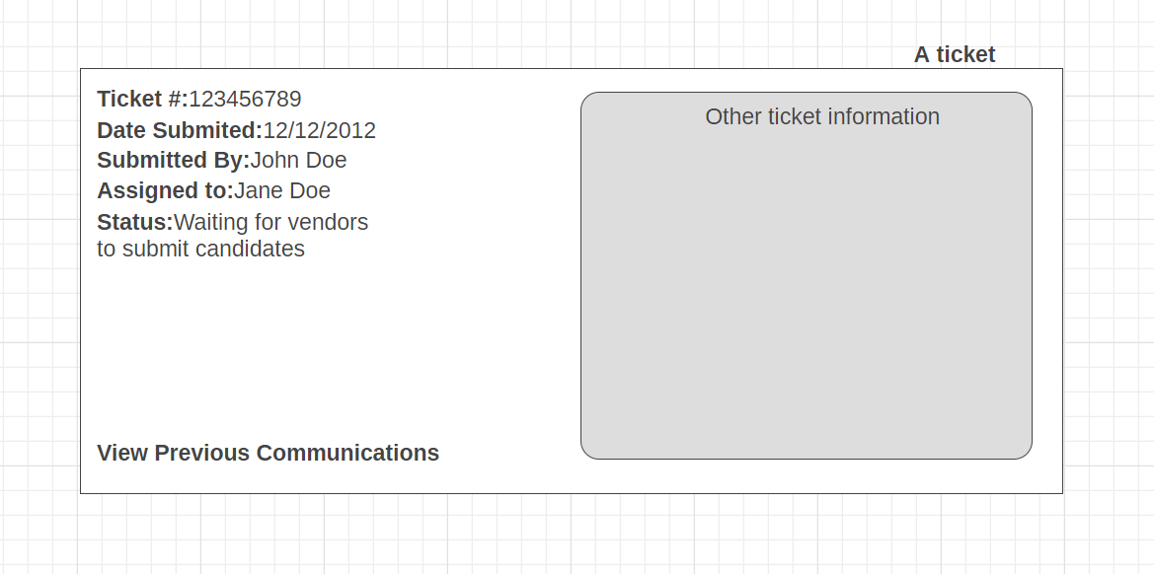

Self-help Tool
Self-help tools are often times used where a decision has to be made or where a dialog on action will occur. It is a program with Artificial Intelligence (AI) and Natural Language Processing (NLP) capabilities. These programs are trained to initiate a course of action based on input (voice, text, gesture etc). The possible courses of action of a self-help tool is dependent on a well thought, clear and concise decision tree process flow. In other words, the success and overall usefulness of a self-help tool is dependent on a decision tree that has been tested and found to be okay within the organizational framework.
The self-help tool is proposed as a tool to improve efficiency because operation process flow maps form the bedrock of the decision trees to be implemented within the self-help tool. A proper implementation will give rise to enriched data for a robust repository on Frequently Asked Questions (FAQ’s), guarantee operational excellence thus having a ripple effect on the adoption of CWM program, enhance communication with relevant stakeholders, reduce waste and improve SLA compliance as well as provide a well suited support.

It will also provide a user friendly interface for stakeholder to easily navigate when trying to hire contractors from suppliers.
Below is a wireframe of a potential self-help tool for the CWM Program:
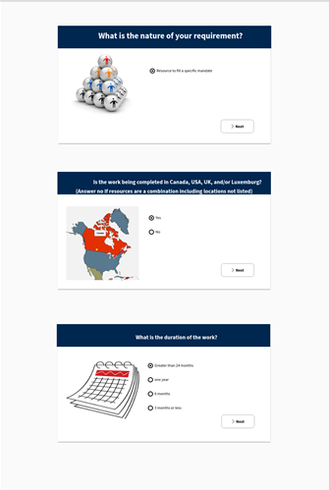

Connect Page
The connect portal serves as a hub for information and help for the Contingent Workforce Management team. It will be linked in email signatures of the team members and introduced to them before launch via an email blast. It will have four main pages, Home, About, Help and News & Discussion. The site is meant to be easy to navigate, intuitive and helpful.
The solution proffered was presented by the group to a larger audience of Senior Management and other members of staff within the EOP (Enterprise Operations and Payment).

Payments and Trade Operations Challenge
Challenge Problem: No current standardized form for CSFI
Client requests that come into CSFI are often mishandled, misrouted, unclear, lack appropriate information or sent to multiple groups at once. This creates delays, errors in information provided, negative client impact. The requests are unqualified, sent in a free-form email (received into a generic mailbox) managed by a gatekeeper who needs to review the entire email before determining what area of the team is capable of fulfilling the request.
To proffer a solution, we drew out the entire process which was necessary to identify the source of the issue CSFI. Upon appreciation of the issue, we came up with three solutions categorized as short, medium and long time solutions.
The short term solution is clearly define the procedure by developing an escalation contacts chart for CSFI client service officer and representative and also provide the organizations contact sheet to client in order to be aware of who to reach out to. This has the benefit of reducing the duplication of work efforts while maximizing efficiency of the CSFI team.
The medium term solution is to develop inquiry forms/templates for clients to use and also integrate these form with existing infrastructure such that it redirect requests to designated business officers and departments. This has the benefit of reducing escalations to incorrect/multiple team as well guarantee a faster work turnover.
Lastly, the long term solution is to add form functionality to RBC Express and the forms would be directed towards service teams for fulfillment and response provided to clients via same channel. The benefit for the long term solution will streamline communication channel and there is a potential for income realization for the service add.
This solution was presented to a bigger audience within PTO.

Summary:
My work term with RBC started with the mandatory trainings for all new hires and subsequently took on the task of tableau development as directed by my Manager. I also had the opportunity to understudy some of the other colleagues in their respective functions within the organization. I participated in two (2) hacks (EOP-CWM hack and PTO challenge) where different problems were examined and solution documented and presented to a wider audience.
The organization and the manager provided an enabling environment with the required tools necessary for success during the work term as well as supervision. The tasks and activities assigned during the work term ensured there is enough to do and that learning was a constant whilst adding value to the operations. The knowledge from database management, data visualizations, software development, data mining and UI/UX courses were all put to good use during the work term.
Overall, it was a great learning experience. A good opportunity to apply concepts taught in the university to real world problems.

Appendix
Audit Reader Objects
Python | Pycontrol.py , Auditreader.py
R | RptGen.R
PL/SQL | AK_script.sql
PL/SQL | OFC_Script.sql
Function | Get_user
Function | Get_drn
Tables and View | AUDIT_TRAIL, AUDIT_ERRORS_AK,AUDIT_ERRORS_CLC,AUDIT_ERRORS_OFC, AUDIT_ERRORS_ALL

Auditreader.py STARTS
import re
import os
import sys

inputfile = sys.argv[1]
operator_line = ""
operator_name = ""
report_date = ""
v_queue = ""
v_session_st_time = ""
pattern_date = "^(([0-9])|([0-2][0-9])|([3][0-1]))/(Jan|Feb|Mar|Apr|May|Jun|Jul|Aug|Sep|Oct|Nov|Dec)/\d{4}$"
pattern_number = r'\d{10}'
pattern_op_num = r'\d{3}'
filepath = inputfile
drn_num =""
op_num = ""
batch_no =""
posting_date = ""
a = ""
with open(filepath) as fp:
for cnt, line in enumerate(fp):
line = line.replace('\n\n', '\n').replace('\n\n', '\n')
line = line.replace(" Resource Allocation Report Workgroup: FSSOperators ",
"")
line = line.replace(" RBC", "")
line = line.replace("*", " ")
line = line.replace("Audit Exceptions Report", "")
line = line.replace(" DRN Oper Activity Chg Before After","")
line = line.replace(" No. Code","")
line = line.replace(" -------------------- ---- ------------------------------- ---- ----------------------------- -----------------------------","")
line = line.replace(
" A session marked with an indicates some data may be lost due to abnormal termination of operator application.",
"")
line = line.replace(" Operator totals and cumulative operator totals do not include Advice Notice sessions.",
"")
line = line.replace(" END OF REPORT","")
if line.find('Page') != -1:
page_line = line.find('Page')

page_diff = len(line) -page_line
page_string = line[page_line:len(line)]
line = line.replace(page_string,"")

if line.find('Cycle:') != -1:
cycleline = line.find('Cycle:')
cycle_string = line[cycleline:cycleline+9]
line = line.replace(cycle_string,"")
if line.find('Host Entry:') != -1:
host_line = line.find('Host Entry:')
host_string = line[host_line:host_line+16]
line = line.replace(host_string,"")
if line.find('Entry:') != -1:
entry_line = line.find('Entry:')
entry_string = line[entry_line:entry_line+13]
line = line.replace(entry_string,"")
if line.find('Posting Date:') != -1:
posting_dt_line = line.find('Posting Date:')
posting_date = line[posting_dt_line+14:posting_dt_line+25]
posting_date_string = line[posting_dt_line:posting_dt_line+25]
line = line.replace(posting_date_string,"")
if line.find('Batch:') != -1:
batch_line = line.find('Batch:')
batch_no = line[batch_line+7:batch_line+12]
batch_no_string = line[batch_line:batch_line+12]
line = line.replace(batch_no_string, "")
op_num = line[23:27]
v_queue = line[29:61]
v_chg_code = line [62:67]
v_before = line [68:98]
v_after = line [99:129]
v_comma = ","
insert_prefix = "insert into audit_trail values ('"
insert_suffix = "');"
old_drn_num = ""
if line.rstrip() =="":
a="a"
else:
a="a"
if re.match(pattern_number, line[11:22]):
drn_num = line[11:22]
old_drn_num = drn_num
else:
a="a"
if v_after.rstrip() =="" and v_before.rstrip() =="" and v_chg_code.rstrip() =="" and v_queue.rstrip()== "" and op_num.rstrip() =="":
a="a"
else:
a= "a"
with open('C:\\Repo\\pto_audit\\output\\db_data.csv','a') as z:
print( batch_no.rstrip(), v_comma.rstrip(), posting_date.rstrip(), v_comma.rstrip(), drn_num.rstrip(), v_comma.rstrip(),
op_num.rstrip(), v_comma.rstrip(), v_queue.rstrip(), v_comma.rstrip(), v_chg_code.rstrip(), v_comma.rstrip(), v_before.rstrip(),
v_comma.rstrip(), v_after.rstrip(),v_comma.rstrip(), cnt, file=z)
#print("Print transformed data ...")
print("#### File ",inputfile,"processing completed!!!")
Auditreader.py ENDS

Pycontrol.py STARTS
with open('C:\\Repo\\pto_audit\\output\\data.ctl','a') as x:
print('LOAD DATA ', file=x)
print("""INFILE 'C:\Repo\pto_audit\output\db_data.csv'""", file =x )
print("""BADFILE 'C:\Repo\pto_audit\output\db_data.bad'""", file =x )
print("""DISCARDFILE 'C:\Repo\pto_audit\output\db_data.dsc' """, file=x)
print('TRUNCATE INTO TABLE audit_trail ' , file=x)
print("""FIELDS TERMINATED BY "," OPTIONALLY ENCLOSED BY '"' TRAILING NULLCOLS """,file=x)
print("(batch_no,posting_dt,drn,op_num,queue,chg_code,before,after,seq)",file=x)
Pycontrol.py ENDS

RptGen.R STARTS
setwd("C:\\Repo\\pto_audit\\Report")
library("RODBC")
connect <- odbcConnect("xe",uid = "pto",pwd = "pto")
dataframe <- sqlQuery(connect, query = "select * from audit_trail where drn in (select drn from audit_errors_ak) and chg_code in ('114','1') order by drn,seq,posting_dt")
write.csv(dataframe,file= "AK_RPT_Detailed.csv",row.names = FALSE)
dataframe <- sqlQuery(connect, query = "select count(1) Number_of_errors,get_user(op_num) NAME,op_num,posting_dt from audit_errors_ak group by posting_dt,op_num order by op_num,posting_dt")
write.csv(dataframe,file= "AK_RPT_Summary.csv",row.names = FALSE)

dataframe <- sqlQuery(connect, query = "select * from audit_trail where drn in (select drn from audit_errors_ofc) and chg_code ='5' order by drn,seq,posting_dt")
write.csv(dataframe,file= "OFC_RPT_Detailed.csv",row.names = FALSE)
dataframe <- sqlQuery(connect, query = "select count(1) Number_of_errors,get_user(op_num) NAME,op_num,posting_dt from audit_errors_ofc group by posting_dt,op_num order by op_num,posting_dt")
write.csv(dataframe,file= "OFC_RPT_Summary.csv",row.names = FALSE)

dataframe <- sqlQuery(connect, query = "select * from audit_trail where drn in (select drn from audit_errors_clc) and chg_code ='10' order by drn,seq,posting_dt")
write.csv(dataframe,file= "CLC_RPT_Detailed.csv",row.names = FALSE)
dataframe <- sqlQuery(connect, query = "select count(1) Number_of_errors,get_user(op_num) NAME,op_num,posting_dt from audit_errors_clc group by posting_dt,op_num order by op_num,posting_dt")
write.csv(dataframe,file= "CLC_RPT_Summary.csv",row.names = FALSE)

dataframe <- sqlQuery(connect, query = "select op_num,count(1) Number_of_occurences,get_user(op_num) name ,rep_module queue ,posting_dt , get_drn(op_num,posting_dt, rep_module) error_desc, 'Input Error' as Error_type , 'Low' as Priority from audit_errors_all group by op_num,rep_module,posting_dt, get_user(op_num) , get_drn(op_num,posting_dt, rep_module) order by get_user(op_num),rep_module")write.csv(dataframe,file= "Consolidated_Summary.csv",row.names = FALSE)odbcClose(connect)
RptGen.R ENDS

PL/SQL for AK queue STARTS
truncate table audit_errors_ak;
DECLARE
v_max_seq audit_trail.seq%type;
v_min_seq audit_trail.seq%type;
v_batch_no audit_trail.batch_no%type;
v_drn audit_trail.drn%type;
v_posting_dt audit_trail.posting_dt%type;
v_chg_code audit_trail.chg_code%type;
v_op_num audit_trail.op_num%type;
v_before audit_trail.before%type;
v_after audit_trail.after%type;
v_seq audit_trail.seq%type;
v_queue audit_trail.queue%type;
v_seq audit_trail.seq%type;
CURSOR vcur
IS
SELECT DISTINCT drn
FROM audit_trail
WHERE drn IN
( SELECT DISTINCT drn FROM audit_trail WHERE chg_code ='114'
)
AND drn NOT IN
(SELECT drn
FROM
(SELECT COUNT(1),
drn
FROM audit_trail
WHERE chg_code IN ('114','1')
GROUP BY drn
HAVING COUNT(1) = 1
)
)
AND NVL(ltrim(rtrim(before)),'xx') <> NVL(ltrim(rtrim(AFTER)),'xx');
BEGIN
FOR i IN vcur
LOOP
SELECT MAX(seq)
INTO v_max_seq
FROM audit_trail
WHERE drn = i.drn
AND chg_code = '1'
AND NVL(ltrim(rtrim(before)),'xx') <> NVL(ltrim(rtrim(AFTER)),'xx');
SELECT MIN(seq)
INTO v_min_seq
FROM audit_trail
WHERE drn = i.drn
AND chg_code = '114'
AND NVL(ltrim(rtrim(before)),'xx') <> NVL(ltrim(rtrim(AFTER)),'xx');
SELECT OP_NUM
INTO V_OP_NUM
FROM audit_trail
WHERE drn = i.drn
AND seq = v_min_seq;
IF v_max_seq <> v_min_seq THEN
SELECT batch_no ,
posting_dt,
queue,
chg_code,
ltrim(rtrim(before)) ,
ltrim(rtrim(AFTER))
INTO v_batch_no ,
v_posting_dt,
v_queue,
v_chg_code,
v_before,
v_after
FROM audit_trail
WHERE drn = i.drn
AND seq = v_max_seq
AND NVL(ltrim(rtrim(before)),'xx') <> NVL(ltrim(rtrim(AFTER)),'xx')
AND chg_code ='1';
SELECT ltrim(rtrim(AFTER))
INTO v_before
FROM audit_trail
WHERE drn = i.drn
AND seq = v_min_seq
AND chg_code ='114'
AND NVL(ltrim(rtrim(before)),'xx') <> NVL(ltrim(rtrim(AFTER)),'xx');
IF v_before <> v_after THEN
INSERT
INTO audit_errors_ak VALUES
(
v_batch_no,
v_posting_dt,
I.DRN,
V_OP_NUM,
v_queue,
v_chg_code ,
v_before,
v_after ,
v_max_seq
);
COMMIT;
END IF;
END IF;
END LOOP;
COMMIT;
END;
/

PL/SQL for AK queue ENDS
PL/SQL for OFC queue Starts
truncate table audit_errors_ofc;

DECLARE
v_seq_max audit_trail.seq%type;
v_seq_min audit_trail.seq%type;
vv_seq audit_trail.seq%type;
v_drn audit_trail.drn%type;
v_after audit_trail.after%type;
v_before audit_trail.before%type;
v_op_num audit_trail.op_num%type;
v_orig_operator audit_trail.op_num%type;
v_chg_code audit_trail.chg_code%type;
v_posting_dt audit_trail.posting_dt%type;
v_batch_no audit_trail.batch_no%type;
v_queue audit_trail.queue%type;
v_work_after_min audit_trail.before%type;
v_work_after_max audit_trail.after%type;
v_op_num_before audit_trail.op_num%type;
v_op_num_after audit_trail.op_num%type;

CURSOR vcur
IS
SELECT DISTINCT drn
FROM audit_trail
WHERE drn IN
(SELECT DISTINCT drn FROM audit_trail WHERE chg_code='5'
)
AND drn IN
(SELECT drn
FROM
( SELECT COUNT(1) , drn FROM audit_trail GROUP BY drn HAVING COUNT(1) <> 1
)
) ;
data_found EXCEPTION;
BEGIN

FOR i IN vcur
LOOP
BEGIN
SELECT MAX(seq),
MIN(seq)
INTO v_seq_max,
v_seq_min
FROM audit_trail
WHERE drn = i.drn
AND chg_code ='5'
AND NVL(before,'xx') <> NVL(AFTER,'xx');

SELECT op_num
INTO v_orig_operator
FROM audit_trail
WHERE seq = v_seq_min
AND chg_code ='5' and drn = i.drn
AND NVL(before,'xx') <> NVL(AFTER,'xx');
IF v_seq_max <> v_seq_min THEN
SELECT AFTER , op_num
INTO v_work_after_min, v_op_num_before
FROM audit_trail
WHERE seq = v_seq_min
AND drn = i.drn;
SELECT AFTER ,op_num
INTO v_work_after_max ,v_op_num_after
FROM audit_trail
WHERE seq = v_seq_max
AND drn = i.drn;
IF v_work_after_min <> v_work_after_max and v_op_num_after <> v_op_num_before THEN
SELECT seq,
drn,
op_num,
batch_no,
before,
AFTER ,
posting_dt ,
chg_code,
queue
INTO vv_seq,
v_drn ,
v_op_num ,
v_batch_no,
v_before ,
v_after ,
v_posting_dt,
v_chg_code,
v_queue
FROM audit_trail
WHERE seq =v_seq_max
AND drn = i.drn
AND NVL(before,'xx') <> NVL(AFTER,'xx') ;
--dbms_output.put_line(vv_seq||' , ' || v_drn ||' , ' || v_op_num||' , ' || v_batch_no||' , ' || v_before ||' , ' || v_after ||' , ' || v_posting_dt||' , '||v_chg_code);
INSERT
INTO audit_errors_ofc VALUES
(
v_batch_no,
v_posting_dt,
v_drn,
v_orig_operator,
v_queue,
v_chg_code,
v_before,
v_after,
vv_seq
);
COMMIT;
END IF;
END IF;

EXCEPTION
WHEN no_data_found THEN
CONTINUE;
END;
END LOOP;
END;
/
PL/SQL for OFC queue Ends

PL/SQL for CLC queue STARTS
truncate table audit_errors_clc;
DECLARE
v_max_seq audit_trail.seq%type;
v_min_seq audit_trail.seq%type;
v_batch_no audit_trail.batch_no%type;
v_drn audit_trail.drn%type;
v_posting_date audit_trail.posting_dt%type;
v_chg_code audit_trail.chg_code%type;
v_op_num audit_trail.op_num%type;
v_before audit_trail.before%type;
v_after audit_trail.after%type;
v_seq audit_trail.seq%type;
v_queue audit_trail.queue%type;
CURSOR vcur
IS
SELECT distinct drn

FROM audit_trail
WHERE (drn) IN
( SELECT drn FROM audit_trail WHERE chg_code ='10'
)
AND drn NOT IN
(SELECT drn
FROM
(SELECT COUNT(1),
drn
FROM audit_trail WHERE chg_code ='10'
GROUP BY drn
HAVING COUNT(1) = 1
)
)
AND chg_code = '10'
AND NVL(before,'xx') <> NVL(AFTER,'xx')
ORDER BY drn;

BEGIN
FOR i IN vcur
LOOP
SELECT MIN(seq),
MAX(seq)
INTO v_min_seq,
v_max_seq
FROM audit_trail
WHERE chg_code = '10'
AND drn =i.drn

AND NVL(before,'xx') <> NVL(AFTER,'xx');
--dbms_output.put_line (i.drn||'~~'||i.batch_no||'~~'||i.before||'~~'||i.after||'~'||v_min_seq||'~~'||v_max_seq);
SELECT batch_no ,
drn,
posting_dt,
chg_code,
op_num,
before,
queue
INTO v_batch_no ,
v_drn,
v_posting_date,
v_chg_code,
v_op_num,
v_before,
v_queue
FROM audit_trail
WHERE drn = i.drn
AND seq = v_min_seq;
SELECT AFTER
INTO v_after
FROM audit_trail
WHERE drn = i.drn
AND seq = v_max_seq;
INSERT
INTO audit_errors_clc VALUES
(
v_batch_no,
v_posting_date,
v_drn,
v_op_num,
v_queue,
v_chg_code,
v_before,
v_after,
v_min_seq
);
COMMIT;
END LOOP;
COMMIT;
END;
/
PL/SQL for CLC queue ENDS

Get_user (PL/SQL function)
create or replace
FUNCTION get_user(
p_op_no IN VARCHAR2)
RETURN VARCHAR2
IS
v_name user_master.name%type;
BEGIN
SELECT name INTO v_name FROM user_master WHERE op_id = p_op_no;
RETURN v_name;
END get_user;
/

Get_drn (PL/SQL function)
CREATE OR REPLACE
FUNCTION get_drn(
p_usr_num IN VARCHAR2,
p_posting_dt IN DATE,
p_module IN VARCHAR2)
RETURN VARCHAR2
IS
drn_output VARCHAR2(32767);
BEGIN
SELECT LISTAGG(drn, ', ') WITHIN GROUP (
ORDER BY op_num)
INTO drn_output
FROM audit_errors_all
WHERE op_num =p_usr_num
AND posting_dt = p_posting_dt
AND rep_module = p_module ;
RETURN drn_output;
END;
/

CREATE TABLE "PTO"."AUDIT_ERRORS_AK"
( "BATCH_NO" VARCHAR2(10 BYTE),
"POSTING_DT" DATE,
"DRN" VARCHAR2(12 BYTE),
"OP_NUM" VARCHAR2(7 BYTE),
"QUEUE" VARCHAR2(30 BYTE),
"CHG_CODE" VARCHAR2(5 BYTE),
"BEFORE" VARCHAR2(200 BYTE),
"AFTER" VARCHAR2(200 BYTE),
"SEQ" VARCHAR2(20 BYTE)
) ;
CREATE TABLE "PTO"."AUDIT_ERRORS_CLC"
( "BATCH_NO" VARCHAR2(10 BYTE),
"POSTING_DT" DATE,
"DRN" VARCHAR2(12 BYTE),
"OP_NUM" VARCHAR2(7 BYTE),
"QUEUE" VARCHAR2(30 BYTE),
"CHG_CODE" VARCHAR2(5 BYTE),
"BEFORE" VARCHAR2(200 BYTE),
"AFTER" VARCHAR2(200 BYTE),
"SEQ" VARCHAR2(20 BYTE)
) ;
CREATE TABLE "PTO"."AUDIT_ERRORS_OFC"
( "BATCH_NO" VARCHAR2(10 BYTE),
"POSTING_DT" DATE,
"DRN" VARCHAR2(12 BYTE),
"OP_NUM" VARCHAR2(7 BYTE),
"QUEUE" VARCHAR2(30 BYTE),
"CHG_CODE" VARCHAR2(5 BYTE),
"BEFORE" VARCHAR2(200 BYTE),
"AFTER" VARCHAR2(200 BYTE),
"SEQ" VARCHAR2(20 BYTE)
) ;
CREATE TABLE "PTO"."AUDIT_TRAIL"
( "BATCH_NO" VARCHAR2(12 BYTE),
"POSTING_DT" DATE,
"DRN" VARCHAR2(14 BYTE),
"OP_NUM" VARCHAR2(9 BYTE),
"QUEUE" VARCHAR2(32 BYTE),
"CHG_CODE" VARCHAR2(7 BYTE),
"BEFORE" VARCHAR2(200 BYTE),
"AFTER" VARCHAR2(200 BYTE),
"SEQ" VARCHAR2(22 BYTE)
) ;
CREATE INDEX "PTO"."IX_AUDIT_DRN" ON "PTO"."AUDIT_TRAIL" ("DRN")
PCTFREE 10 INITRANS 2 MAXTRANS 255 COMPUTE STATISTICS
STORAGE(INITIAL 65536 NEXT 1048576 MINEXTENTS 1 MAXEXTENTS 2147483645
PCTINCREASE 0 FREELISTS 1 FREELIST GROUPS 1 BUFFER_POOL DEFAULT FLASH_CACHE DEFAULT CELL_FLASH_CACHE DEFAULT)
TABLESPACE "SYSTEM" ;
CREATE TABLE "PTO"."AUDIT_ERRORS"
( "BATCH_NO" VARCHAR2(10 BYTE),
"POSTING_DT" DATE,
"DRN" VARCHAR2(12 BYTE),
"OP_NUM" VARCHAR2(7 BYTE),
"QUEUE" VARCHAR2(30 BYTE),
"CHG_CODE" VARCHAR2(5 BYTE),
"BEFORE" VARCHAR2(200 BYTE),
"AFTER" VARCHAR2(200 BYTE),
"SEQ" VARCHAR2(20 BYTE)
) ;
CREATE TABLE "PTO"."USER_MASTER"
( "OP_ID" VARCHAR2(5 BYTE),
"NAME" VARCHAR2(100 BYTE),
"TITLE" VARCHAR2(15 BYTE),
"TEAM" VARCHAR2(25 BYTE),
"SHIFT" VARCHAR2(20 BYTE),
"OPR_ID" VARCHAR2(5 BYTE)
) ;
CREATE OR REPLACE FORCE VIEW "PTO"."AUDIT_ERRORS_ALL" ("BATCH_NO", "POSTING_DT", "DRN", "OP_NUM", "QUEUE", "CHG_CODE", "BEFORE", "AFTER", "SEQ", "REP_MODULE") AS
select aa."BATCH_NO",aa."POSTING_DT",aa."DRN",aa."OP_NUM",aa."QUEUE",aa."CHG_CODE",aa."BEFORE",aa."AFTER",aa."SEQ", 'CLC' as REP_MODULE from audit_errors_clc aa
union all
select bb."BATCH_NO",bb."POSTING_DT",bb."DRN",bb."OP_NUM",bb."QUEUE",bb."CHG_CODE",bb."BEFORE",bb."AFTER",bb."SEQ", 'OFC' as REP_MODULE from audit_errors_ofc bb
union all
select cc."BATCH_NO",cc."POSTING_DT",cc."DRN",cc."OP_NUM",cc."QUEUE",cc."CHG_CODE",cc."BEFORE",cc."AFTER",cc."SEQ" , 'AK' as REP_MODULE from audit_errors_ak cc;

